Overlapping Segment Intersection

Definition
# Source: AI Source: Provided by: [Data Path: Persons Table -> ID Column: 1, Name_En Column: Motasem Essam] -> From: [ChatGPT] on [7/25/2026]
Overlapping Segment Intersection is a type of Segment Intersection that occurs when two line segments lie on the same straight line and share a portion of their length.
Unlike a point intersection, where two segments share only one point, overlapping segments share infinitely many points.
If segments $\overline{AB}$ and $\overline{CD}$ overlap, their intersection is itself a line segment:
$$\boxed{\overline{AB}∩\overline{CD}=\overline{PQ}}$$
where $\overline{PQ}$ is the common portion of the two segments.
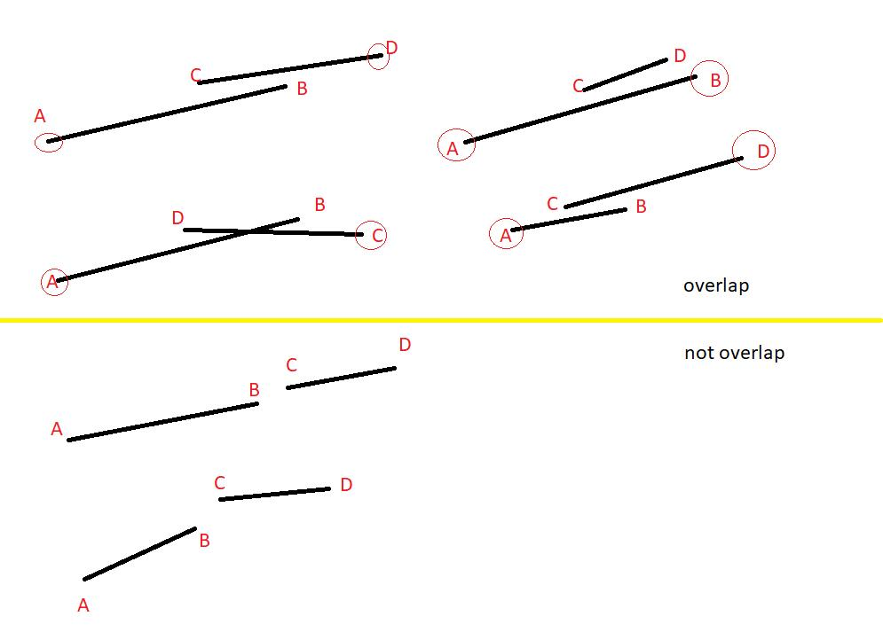
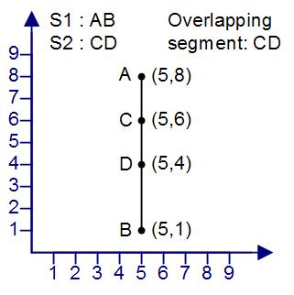
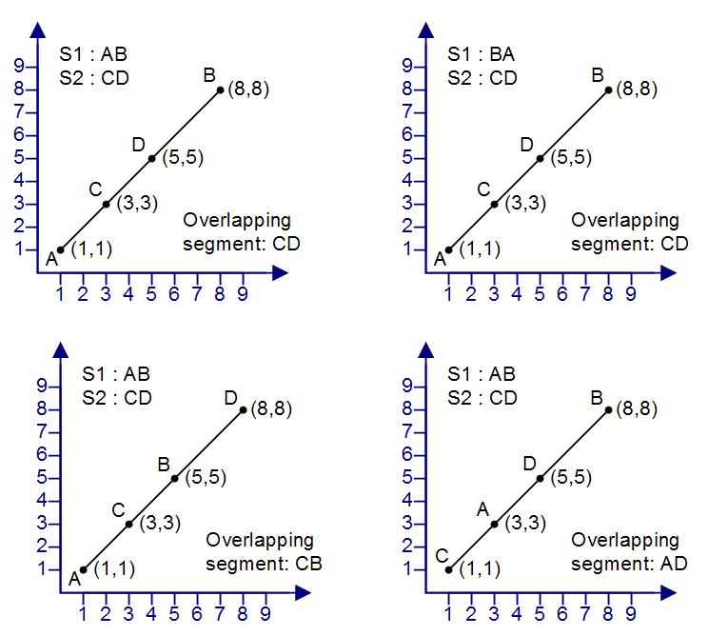

Purpose
# Source: AI Source: Provided by: [Data Path: Persons Table -> ID Column: 1, Name_En Column: Motasem Essam] -> From: [ChatGPT] on [7/25/2026]
Overlapping segment intersection is used to:
- Identify segments that share part of the same path.
- Determine common geometric boundaries.
- Analyze collinear line segments.
- Find shared portions of polygons.
- Detect duplicate or overlapping objects.
- Analyze maps and road networks.
- Support CAD and GIS operations.
- Perform computational geometry calculations.

Fundamental Idea
# Source: AI Source: Provided by: [Data Path: Persons Table -> ID Column: 1, Name_En Column: Motasem Essam] -> From: [ChatGPT] on [7/25/2026]
For two segments to overlap, three conditions are important:
- They must lie on the same straight line.
- They must have a common portion.
- That common portion must contain more than one point.
For example:
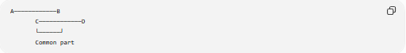
A────────────B
C────────────D
└──────┘
Common part
The common portion is a segment rather than a single point.
Therefore:
$$\boxed{\overline{AB}∩\overline{CD}=\overline{CB}}$$
assuming $C$ lies between $A$ and $B$.

Mathematical Representation
# Source: AI Source: Provided by: [Data Path: Persons Table -> ID Column: 1, Name_En Column: Motasem Essam] -> From: [ChatGPT] on [7/25/2026]
Suppose:
$$\overline{AB}$$
and:
$$\overline{CD}$$
are collinear and overlap.
Their intersection can be represented as:
$$\boxed{\overline{AB}∩\overline{CD}=\overline{PQ}}$$
where $P$ and $Q$ are the endpoints of the common portion.
Because every point between P and Q belongs to both segments:
$$\boxed{\text{Number of common points}=∞}$$

Simple Example
# Source: AI Source: Provided by: [Data Path: Persons Table -> ID Column: 1, Name_En Column: Motasem Essam] -> From: [ChatGPT] on [7/25/2026]
Consider:
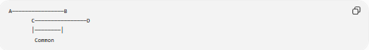
A────────────────B
C────────────────D
│────────│
Common
Here:
$$C∈\overline{AB}$$
and:
$$B∈\overline{CD}$$
Therefore, the common portion is:
$$\boxed{\overline{CB}}$$
and:
$$\boxed{\overline{AB}∩\overline{CD}=\overline{CB}}$$
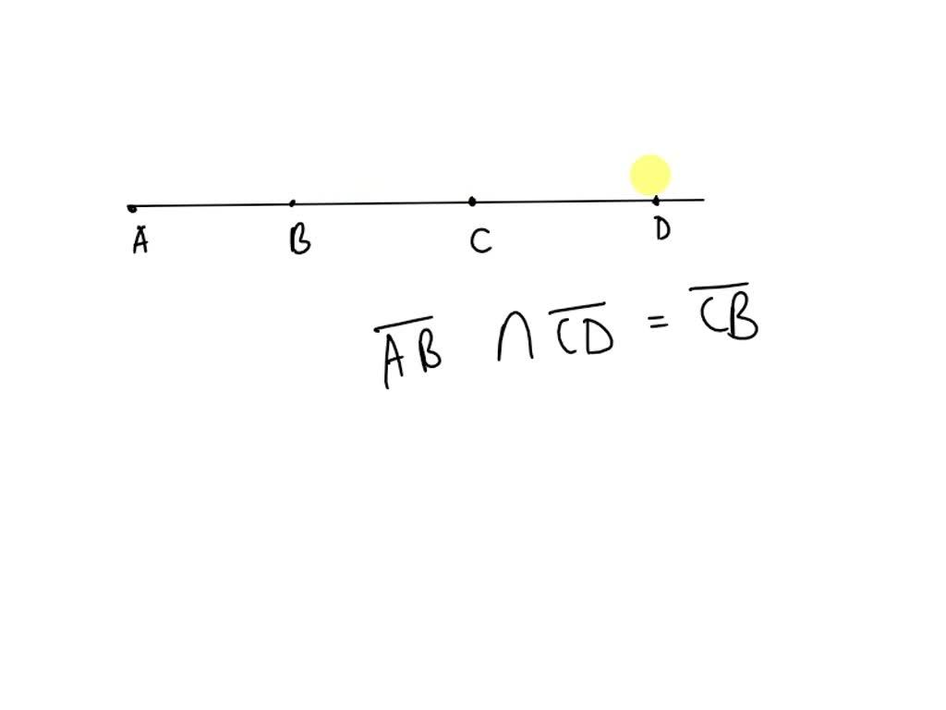

Overlapping Segments Are Collinear
# Source: AI Source: Provided by: [Data Path: Persons Table -> ID Column: 1, Name_En Column: Motasem Essam] -> From: [ChatGPT] on [7/25/2026]
The segments must lie on the same straight line.
For example:
$$\overline{AB}$$
and:
$$\overline{CD}$$
are collinear if they lie on the same line.
If they are on different lines, they cannot form an overlapping segment intersection.
Thus:
$$\boxed{\text{Overlapping}⇒\text{Collinear}}$$

Types of Overlap
There are several possible arrangements.

1. Partial Overlap
# Source: AI Source: Provided by: [Data Path: Persons Table -> ID Column: 1, Name_En Column: Motasem Essam] -> From: [ChatGPT] on [7/25/2026]
Only part of one segment overlaps part of the other.
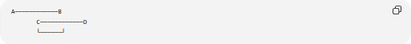
A────────────B
C────────────D
└──────┘
The intersection is:
$$\boxed{\overline{CB}}$$

2. One Segment Completely Inside Another
# Source: AI Source: Provided by: [Data Path: Persons Table -> ID Column: 1, Name_En Column: Motasem Essam] -> From: [ChatGPT] on [7/25/2026]
One segment can lie completely inside another.
A────────────────────D
B────────C
Here:
$$\overline{BC}⊂\overline{AD}$$
Therefore:
$$\boxed{\overline{AD}∩\overline{BC}=\overline{BC}}$$
The entire smaller segment is the intersection.

3. Identical Segments
# Source: AI Source: Provided by: [Data Path: Persons Table -> ID Column: 1, Name_En Column: Motasem Essam] -> From: [ChatGPT] on [7/25/2026]
Two segments can have exactly the same endpoints.
A────────────────B
A────────────────B
In this case:
$$\boxed{\overline{AB}∩\overline{AB}=\overline{AB}}$$
The two segments completely overlap.
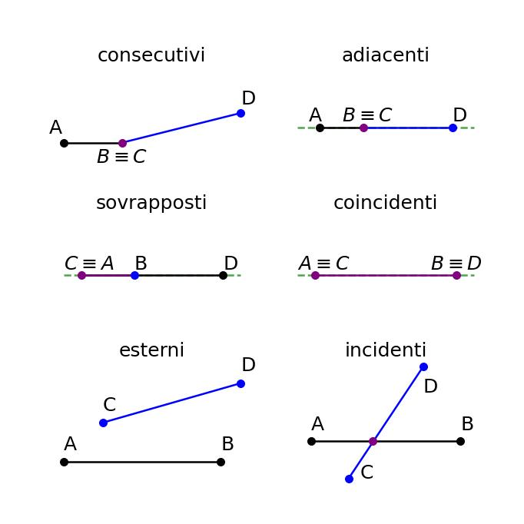

4. Overlap at an Endpoint Only
# Source: AI Source: Provided by: [Data Path: Persons Table -> ID Column: 1, Name_En Column: Motasem Essam] -> From: [ChatGPT] on [7/25/2026]
This is an important distinction.
Consider:
A────────B────────C
Segments:
$$\overline{AB}$$
and:
$$\overline{BC}$$
share only $B$.
Therefore:
$$\boxed{\overline{AB}∩\overline{BC}=B}$$
This is Endpoint Intersection, not Overlapping Segment Intersection.
Why?
Because they share only one point, not a segment of positive length.
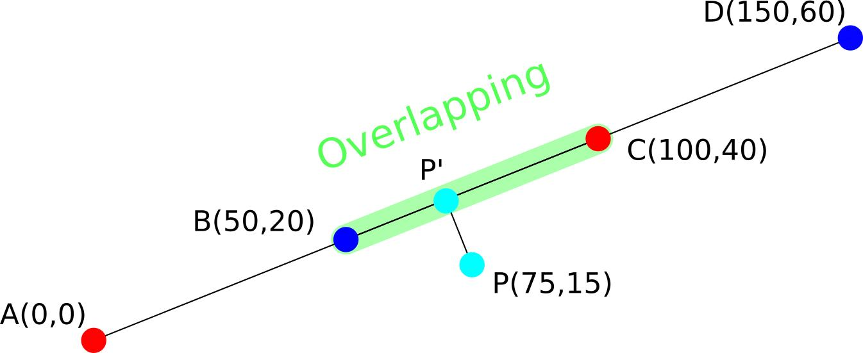

Overlapping Segment vs. Point Intersection
# Source: AI Source: Provided by: [Data Path: Persons Table -> ID Column: 1, Name_En Column: Motasem Essam] -> From: [ChatGPT] on [7/25/2026]
The major difference is the number of common points.
Point Intersection
$$\boxed{\overline{AB}∩\overline{CD}=P}$$
There is exactly one common point.
Overlapping Segment Intersection
$$\boxed{\overline{AB}∩\overline{CD}=\overline{PQ}}$$
There are infinitely many common points.
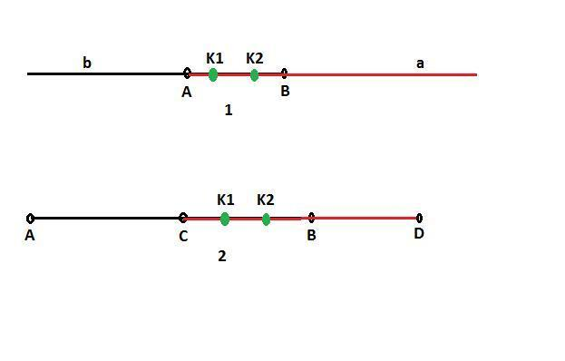

Overlapping Segment vs. Interior Intersection
# Source: AI Source: Provided by: [Data Path: Persons Table -> ID Column: 1, Name_En Column: Motasem Essam] -> From: [ChatGPT] on [7/25/2026]
An Interior Intersection normally means two segments cross at a single point inside both segments:
$$\boxed{\overline{AB}∩\overline{CD}=P}$$
An Overlapping Segment Intersection means the common part has length:
$$\boxed{PQ>0}$$
and:
$$\boxed{\overline{AB}∩\overline{CD}=\overline{PQ}}$$
Therefore, the intersection contains infinitely many points.

Length of the Overlapping Portion
# Source: AI Source: Provided by: [Data Path: Persons Table -> ID Column: 1, Name_En Column: Motasem Essam] -> From: [ChatGPT] on [7/25/2026]
If the overlapping portion is:
$$\overline{PQ}$$
then its length is:
$$\boxed{L=\left|PQ\right|}$$
For example, if:
$$P=\left(2,0\right)$$
and:
$$Q=\left(7,0\right)$$
then:
$$\boxed{L=7-2=5}$$
The two original segments share a common length of $5$ units.

Example on a Number Line
# Source: AI Source: Provided by: [Data Path: Persons Table -> ID Column: 1, Name_En Column: Motasem Essam] -> From: [ChatGPT] on [7/25/2026]
Suppose:
$$\overline{AB}=\left[1,8\right]$$
and:
$$\overline{CD}=\left[5,10\right]$$
The common interval is:
$$\left[5,8\right]$$
Therefore:
$$\boxed{\left[1,8\right]∩\left[5,10\right]=\left[5,8\right]}$$
and the overlap length is:
$$\boxed{8-5=3}$$
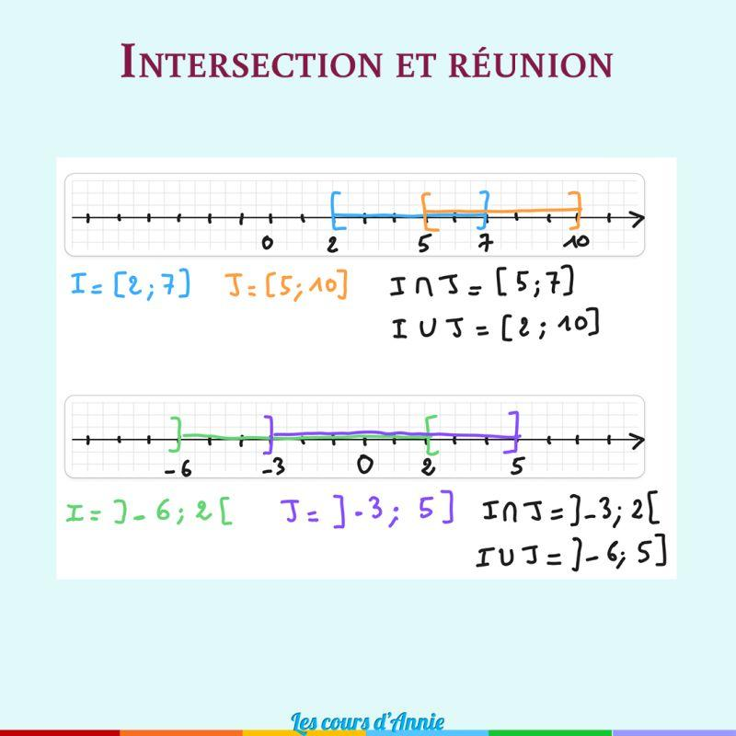
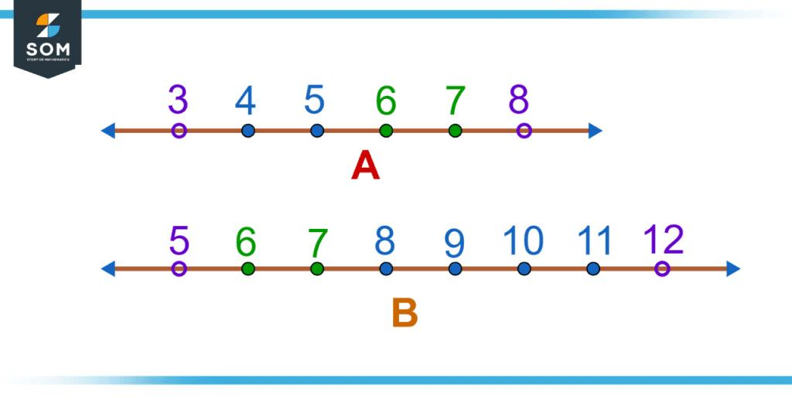
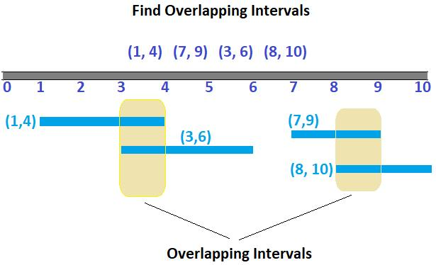

Mathematical Condition for Overlap
# Source: AI Source: Provided by: [Data Path: Persons Table -> ID Column: 1, Name_En Column: Motasem Essam] -> From: [ChatGPT] on [7/25/2026]
For one-dimensional segments represented by intervals:
$$\left[a,b\right]$$
and:
$$\left[c,d\right]$$
they overlap with positive length when:
$$\boxed{\max\left(a,c\right)<\min\left(b,d\right)}$$
The common interval is:
$$\boxed{\left[\max\left(a,c\right),\min\left(b,d\right)\right]}$$
and its length is:
$$\boxed{\min\left(b,d\right)-\max\left(a,c\right)}$$
provided that:
$$\boxed{\max\left(a,c\right)<\min\left(b,d\right)}$$

Endpoint Touching Condition
# Source: AI Source: Provided by: [Data Path: Persons Table -> ID Column: 1, Name_En Column: Motasem Essam] -> From: [ChatGPT] on [7/25/2026]
If:
$$\boxed{\max\left(a,c\right)=\min\left(b,d\right)}$$
then the segments only touch at one point.
For example:
$$\left[1,5\right]$$
and:
$$\left[5,9\right]$$
have:
$$\left[1,5\right]∩\left[5,9\right]=5$$
This is an Endpoint Intersection, not an overlapping segment intersection.

Coordinate Geometry
# Source: AI Source: Provided by: [Data Path: Persons Table -> ID Column: 1, Name_En Column: Motasem Essam] -> From: [ChatGPT] on [7/25/2026]
Consider two horizontal segments:
$$A=\left(1,2\right), B=\left(8,2\right)$$
and:
$$C=\left(4,2\right), D=\left(10,2\right)$$
They are collinear because they have the same (y)-coordinate:
$$y=2$$
Their (x)-intervals are:
$$\left[1,8\right]$$
and:
$$\left[4,10\right]$$
Therefore:
$$\left[1,8\right]∩\left[4,10\right]=\left[4,8\right]$$
So the overlapping segment is:
$$\boxed{\overline{CB}}$$
with length:
$$\boxed{4}$$

Vertical Overlapping Segments
# Source: AI Source: Provided by: [Data Path: Persons Table -> ID Column: 1, Name_En Column: Motasem Essam] -> From: [ChatGPT] on [7/25/2026]
Overlapping segments do not have to be horizontal.
For example:
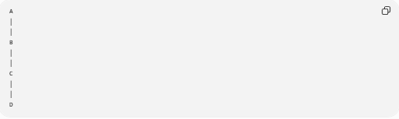
A
│
│
B
│
│
C
│
│
D
If two vertical segments share a portion, they also form an overlapping segment intersection.
For example:
$$\overline{AD}∩\overline{BC}=\overline{BC}$$

Diagonal Overlapping Segments
# Source: AI Source: Provided by: [Data Path: Persons Table -> ID Column: 1, Name_En Column: Motasem Essam] -> From: [ChatGPT] on [7/25/2026]
Overlapping segments can also lie along any straight direction.
The important requirement is that they are collinear.
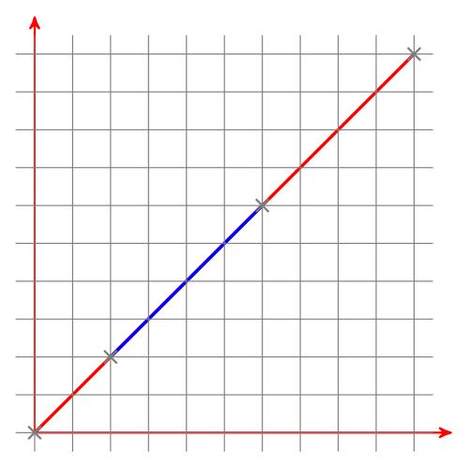
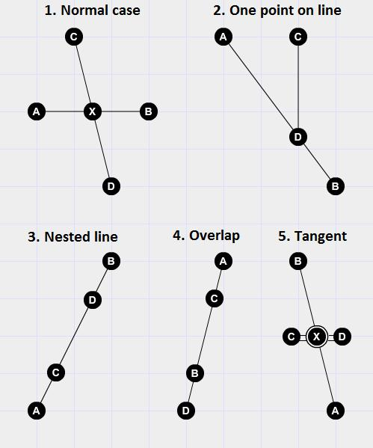

Overlapping Polygon Edges
# Source: AI Source: Provided by: [Data Path: Persons Table -> ID Column: 1, Name_En Column: Motasem Essam] -> From: [ChatGPT] on [7/25/2026]
Two polygons can have edges that overlap.
For example, two shapes may share part of the same boundary.
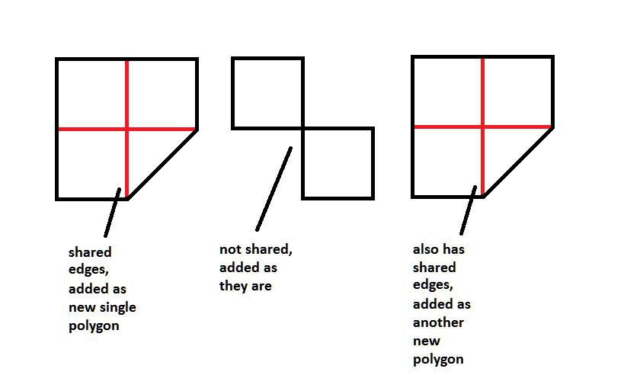
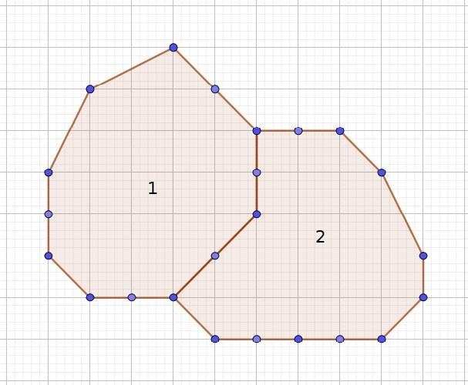
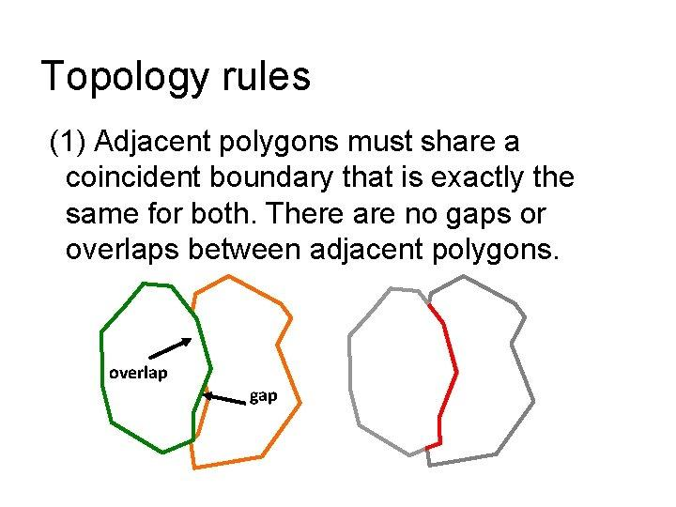
In this situation, the common boundary is an overlapping segment.
This is important in:
- Computational geometry.
- CAD.
- GIS.
- Polygon clipping.
- Map analysis.

Overlapping Boundaries
# Source: AI Source: Provided by: [Data Path: Persons Table -> ID Column: 1, Name_En Column: Motasem Essam] -> From: [ChatGPT] on [7/25/2026]
Two geometric figures may share part of their boundaries.
For example:
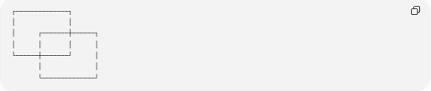
┌──────────────┐
│ │
│ ┌───────┼──────┐
│ │ │ │
└──────┼───────┘ │
│ │
└──────────────┘
The shared boundary portion is an overlapping segment.

Overlapping Segment Intersection in Polygons
# Source: AI Source: Provided by: [Data Path: Persons Table -> ID Column: 1, Name_En Column: Motasem Essam] -> From: [ChatGPT] on [7/25/2026]
Suppose two polygons share part of one edge.
Then their boundaries can satisfy:
$$\boxed{E_{1}∩E_{2}=\overline{PQ}}$$
where $E_{1}$ and $E_{2}$ are polygon edges.
This is different from two polygon edges meeting only at a vertex:
$$\boxed{E_{1}∩E_{2}=P}$$

Overlapping Segments and Polylines
# Source: AI Source: Provided by: [Data Path: Persons Table -> ID Column: 1, Name_En Column: Motasem Essam] -> From: [ChatGPT] on [7/25/2026]
A polyline consists of connected line segments.
Two polylines may contain segments that overlap.
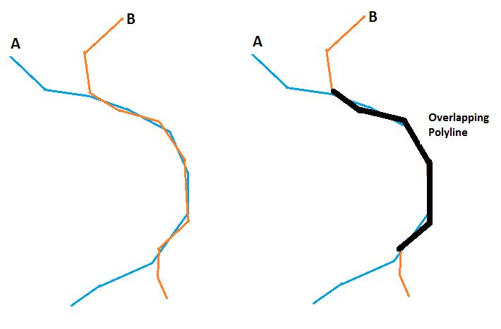
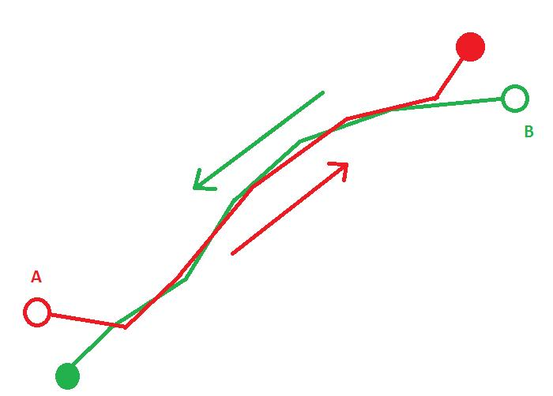
This can occur when:
- Two routes follow the same road.
- Two paths share part of a trail.
- Two CAD paths use the same boundary.
- Two GIS features share part of an edge.

Overlapping Segments in CAD
# Source: AI Source: Provided by: [Data Path: Persons Table -> ID Column: 1, Name_En Column: Motasem Essam] -> From: [ChatGPT] on [7/25/2026]
CAD systems need to detect overlapping segments because duplicate geometry can cause problems.
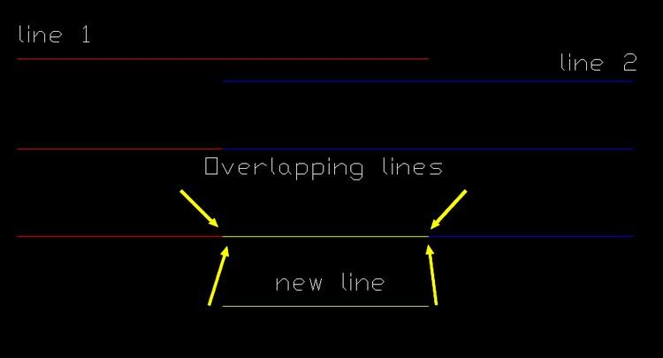
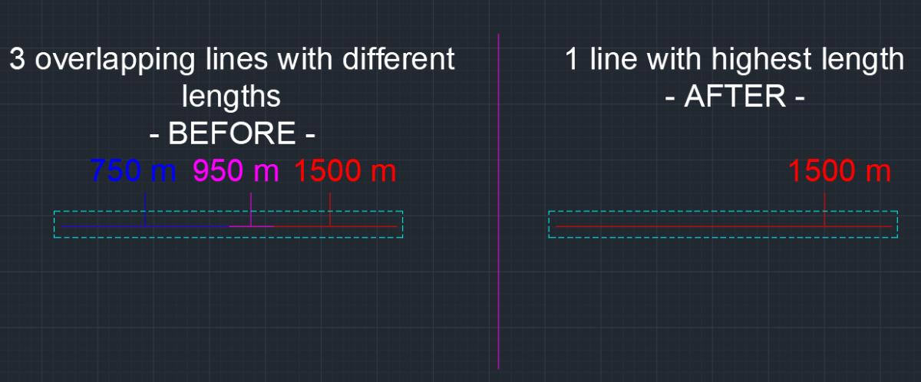
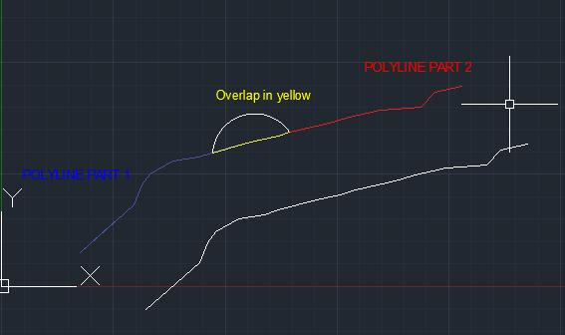
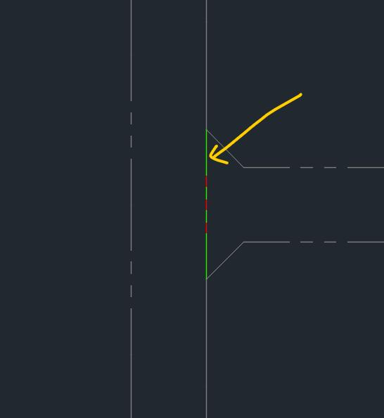
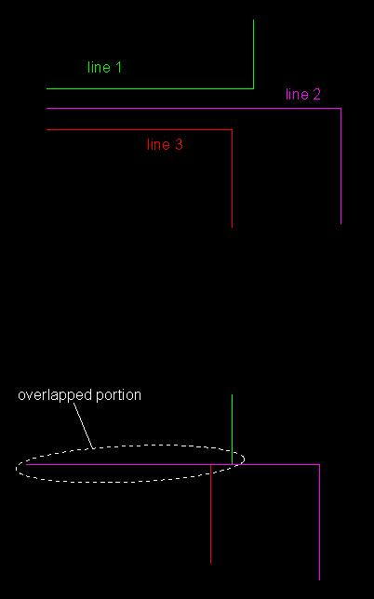
Overlapping detection can be used to:
- Remove duplicate geometry.
- Trim segments.
- Merge segments.
- Create boundaries.
- Clean technical drawings.
- Detect shared edges.

Overlapping Segments in GIS
# Source: AI Source: Provided by: [Data Path: Persons Table -> ID Column: 1, Name_En Column: Motasem Essam] -> From: [ChatGPT] on [7/25/2026]
In GIS, two line features can share part of the same path.
Examples include:
- Two roads sharing a section.
- Two administrative boundaries sharing an edge.
- Two routes using the same road.
- Two utility lines following the same path.
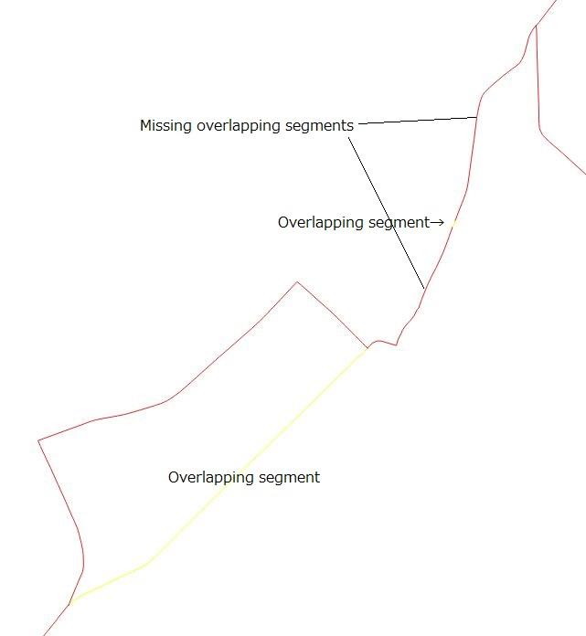
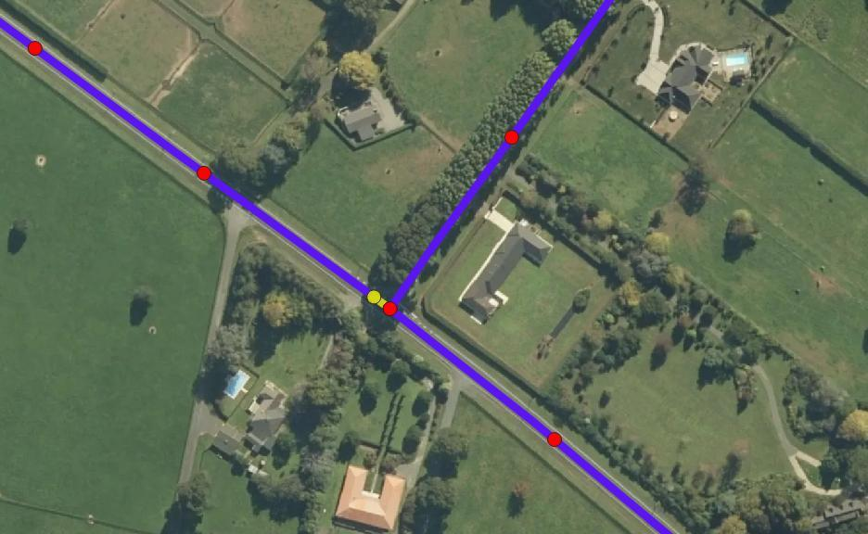
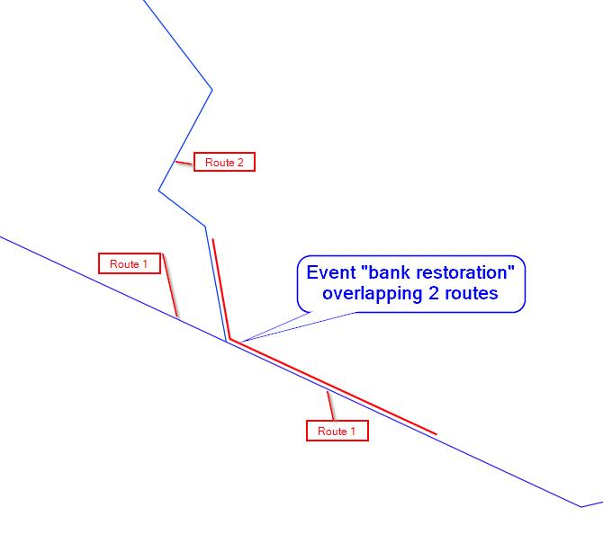
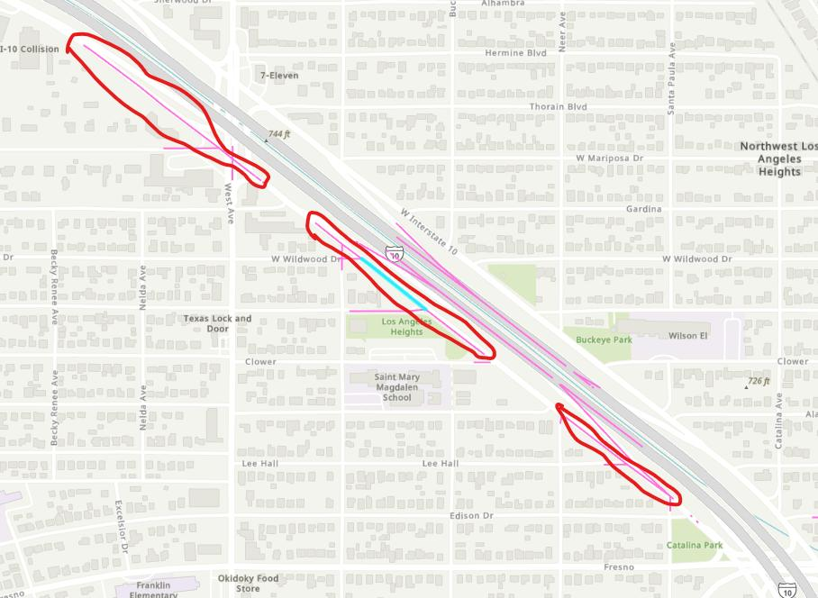

Overlapping Segments in Computer Graphics
# Source: AI Source: Provided by: [Data Path: Persons Table -> ID Column: 1, Name_En Column: Motasem Essam] -> From: [ChatGPT] on [7/25/2026]
Computer graphics uses overlap detection for:
- Polygon clipping.
- Vector graphics.
- Collision detection.
- Shape operations.
- Path processing.
- Mesh construction.

Real-World Examples
# Source: AI Source: Provided by: [Data Path: Persons Table -> ID Column: 1, Name_En Column: Motasem Essam] -> From: [ChatGPT] on [7/25/2026]
Overlapping segment intersections can represent:
- Two roads sharing part of a route.
- Two railway tracks represented by the same geometric path.
- Two walls sharing a portion of a boundary.
- Two construction lines lying on the same path.
- Two map boundaries sharing an edge.
- Two routes following the same trail.
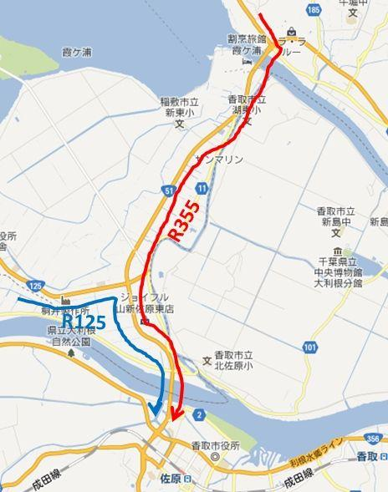
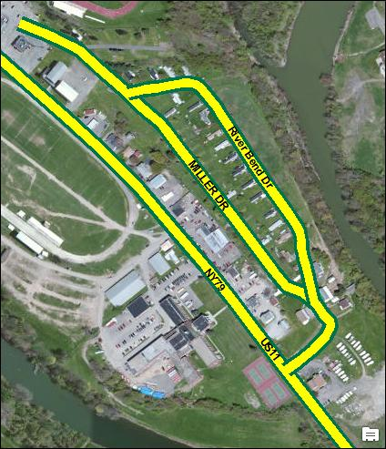
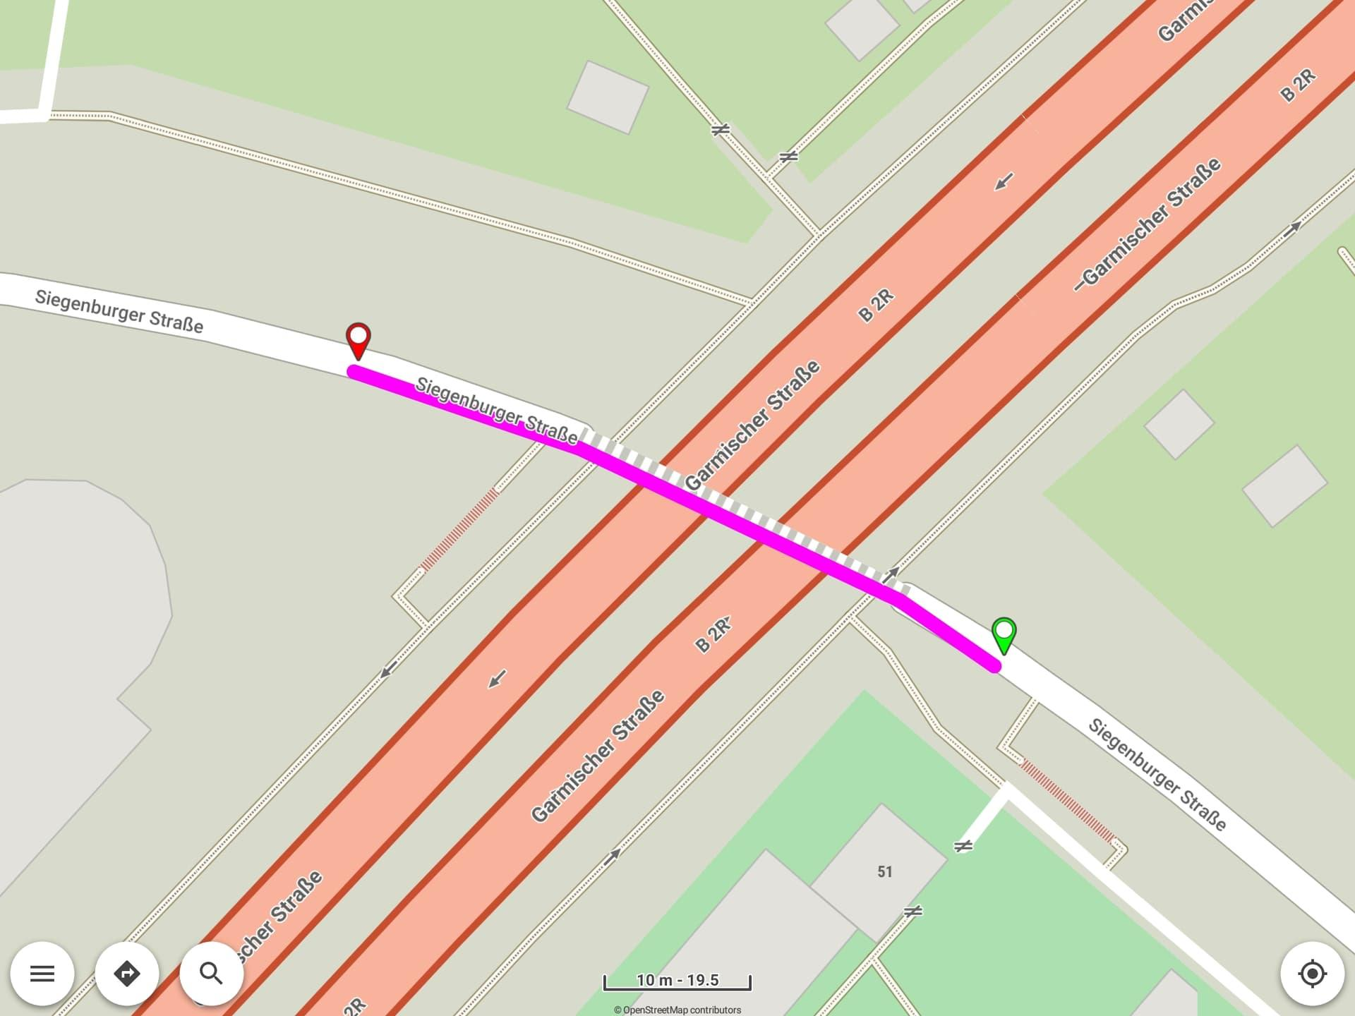
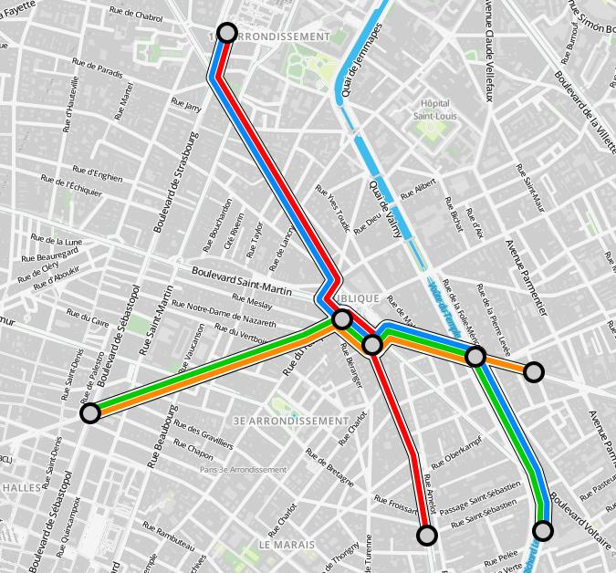

Applications
# Source: AI Source: Provided by: [Data Path: Persons Table -> ID Column: 1, Name_En Column: Motasem Essam] -> From: [ChatGPT] on [7/25/2026]
Overlapping segment intersection is important in:
- Plane Geometry
- Coordinate Geometry
- Computational Geometry
- Polygon Theory
- Polyline Geometry
- CAD
- GIS
- Architecture
- Engineering
- Surveying
- Cartography
- Computer Graphics
- Robotics
- Navigation

Advantages
# Source: AI Source: Provided by: [Data Path: Persons Table -> ID Column: 1, Name_En Column: Motasem Essam] -> From: [ChatGPT] on [7/25/2026]
Studying overlapping segment intersections helps to:
- Detect shared geometric portions.
- Calculate common lengths.
- Identify duplicate geometry.
- Analyze shared boundaries.
- Merge collinear segments.
- Simplify geometric models.
- Detect common routes.
- Support CAD and GIS operations.
- Improve computational geometry algorithms.

Limitations
# Source: AI Source: Provided by: [Data Path: Persons Table -> ID Column: 1, Name_En Column: Motasem Essam] -> From: [ChatGPT] on [7/25/2026]
Overlapping segment intersection:
- Requires the segments to be collinear.
- Is more complex to detect than a simple point intersection.
- Must be distinguished from endpoint touching.
- Can create duplicate geometry in CAD or GIS systems.
- Requires special handling in computational geometry algorithms.
- May involve infinitely many common points.

Comparison with Related Concepts
# Source: AI Source: Provided by: [Data Path: Persons Table -> ID Column: 1, Name_En Column: Motasem Essam] -> From: [ChatGPT] on [7/25/2026]
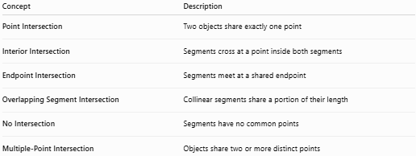
Concept | Description
Point Intersection | Two objects share exactly one point
Interior Intersection | Segments cross at a point inside both segments
Endpoint Intersection | Segments meet at a shared endpoint
Overlapping Segment Intersection | Collinear segments share a portion of their length
No Intersection | Segments have no common points
Multiple-Point Intersection | Objects share two or more distinct points

Important Distinction
# Source: AI Source: Provided by: [Data Path: Persons Table -> ID Column: 1, Name_En Column: Motasem Essam] -> From: [ChatGPT] on [7/25/2026]
Consider these three cases:
1. Endpoint Intersection
$$\left[1,5\right]∩\left[5,9\right]=5$$
One common point.
2. Overlapping Segment Intersection
$$\left[1,8\right]∩\left[5,10\right]=\left[5,8\right]$$
A common segment.
3. No Intersection
$$\left[1,3\right]∩\left[5,9\right]=∅$$
No common points.
Therefore:
$$\boxed{\begin{aligned}\text{One point}→\text{Point/Endpoint Intersection} \\ \text{Segment}→\text{Overlapping Intersection} \\ \text{Empty}→\text{No Intersection}\end{aligned}}$$

Key Points
# Source: AI Source: Provided by: [Data Path: Persons Table -> ID Column: 1, Name_En Column: Motasem Essam] -> From: [ChatGPT] on [7/25/2026]
- Overlapping Segment Intersection occurs when two line segments are collinear and share part of their length.
- The intersection is itself a line segment:
$$\boxed{\overline{AB}∩\overline{CD}=\overline{PQ}}$$
- An overlapping intersection contains infinitely many points.
- Partial overlap is possible.
- One segment can be completely contained inside another.
- Two identical segments can completely overlap.
- If segments only touch at one endpoint, it is Endpoint Intersection, not overlapping intersection.
- The overlap length can be calculated as:
$$\boxed{L=\min\left(b,d\right)-\max\left(a,c\right)}$$
when:
$$\boxed{\max\left(a,c\right)<\min\left(b,d\right)}$$
- Overlapping segments are important in geometry, polygons, polylines, CAD, GIS, engineering, surveying, and computer graphics.

Conclusion
# Source: AI Source: Provided by: [Data Path: Persons Table -> ID Column: 1, Name_En Column: Motasem Essam] -> From: [ChatGPT] on [7/25/2026]
Overlapping Segment Intersection is a type of segment intersection in which two collinear line segments share a common portion of their length. Unlike a point intersection, the intersection is not a single point but another line segment containing infinitely many points. Overlap can be partial, complete containment, or complete coincidence. Correctly identifying overlapping segments is important for analyzing geometric boundaries, polygons, polylines, coordinate geometry, CAD models, GIS data, engineering designs, and computer graphics.

